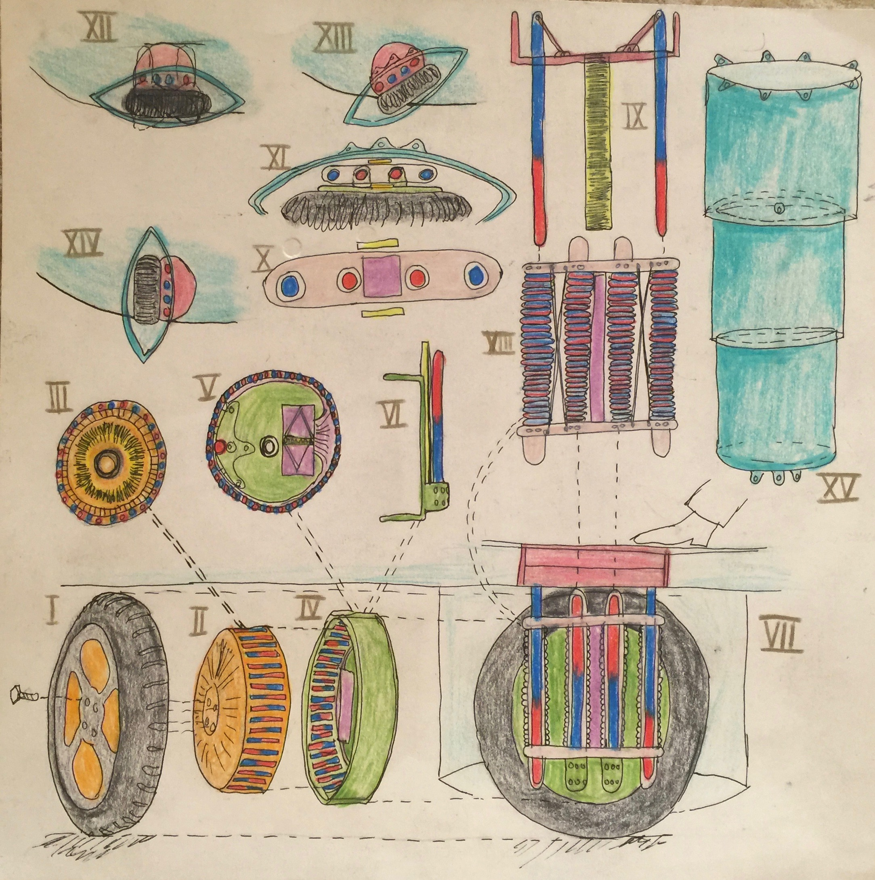Klima Ko-op

Week ending Sun 24 Jan 2016

Wheel Progress Report

# Achieved Mon 18 Jan – Sun 24 Jan 2016

Since peer review.

**Jig for Metal Cutting:** Designed jig to hold metal pieces in place while cutting them with my electric saw. This jig has three parts: end stop, stock support and main body. I’ve designed the OpenSCAD for the first two and 3D printed them, with these being good prints (I since modified the design so am reprinting). I bought the right saw blades. The jig (as designed) fits my power saw exactly. [Status not yet finished; I made a mistake in alignment, after optimising the stock support!!] The below is part of the jig, together with all of the types of steel.

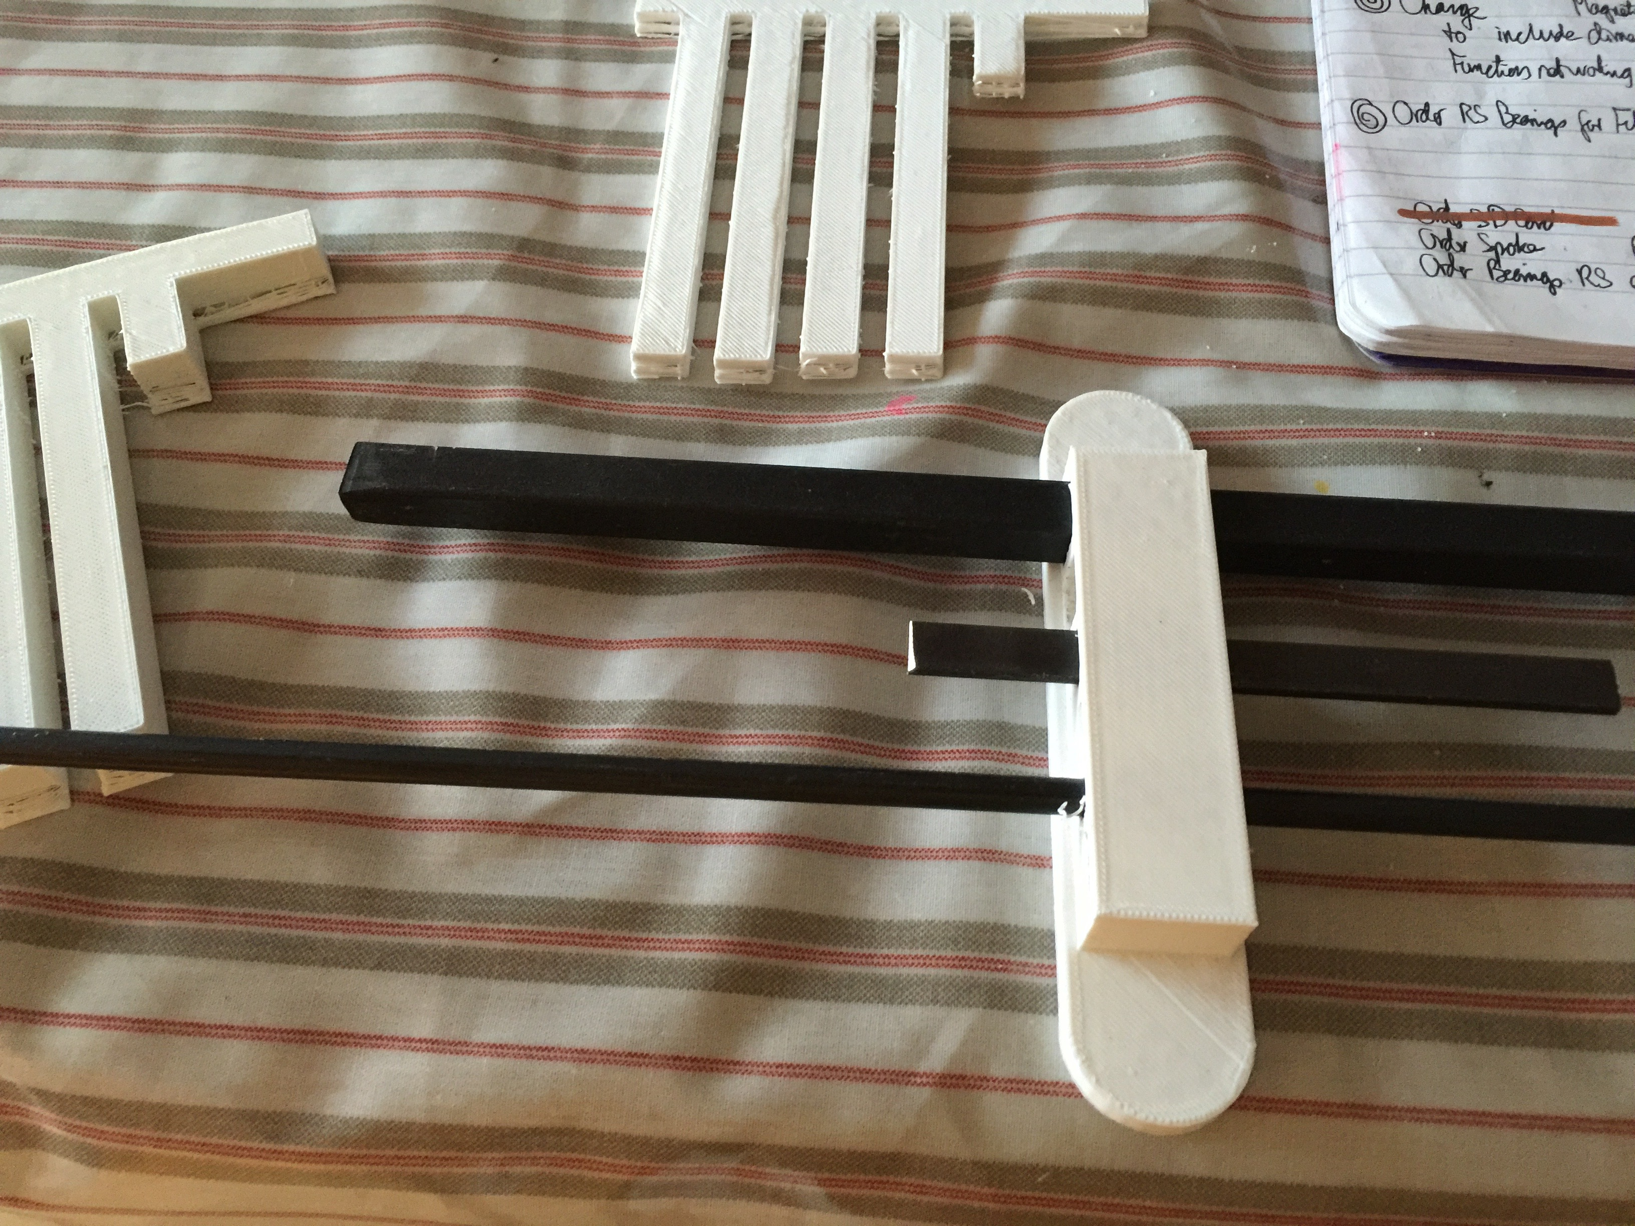

* The Y-axis of my 3D printer was occasionally slipping its belt by a tooth from time to time. Some prints had two or more steps of Y-axis movement as the layers built up in the Z-axis – so I needed to tighten the belt. Tightened belt.
* Y end stop broke. Mended it. I’ve ordered new end stops.
* Also the bed touching a cable to the LCD front control panel caused some print errors. Some by my laptop screen touching. Put a longer cable on, and moved obstacles out the way.
* Also the filament stops flowing sometimes, seems to be too much friction in feed reel. Obtained personal advice (off Reddit) on putting a ball race on the rod giving friction. Ordered ball races (from China) of exactly the right size.

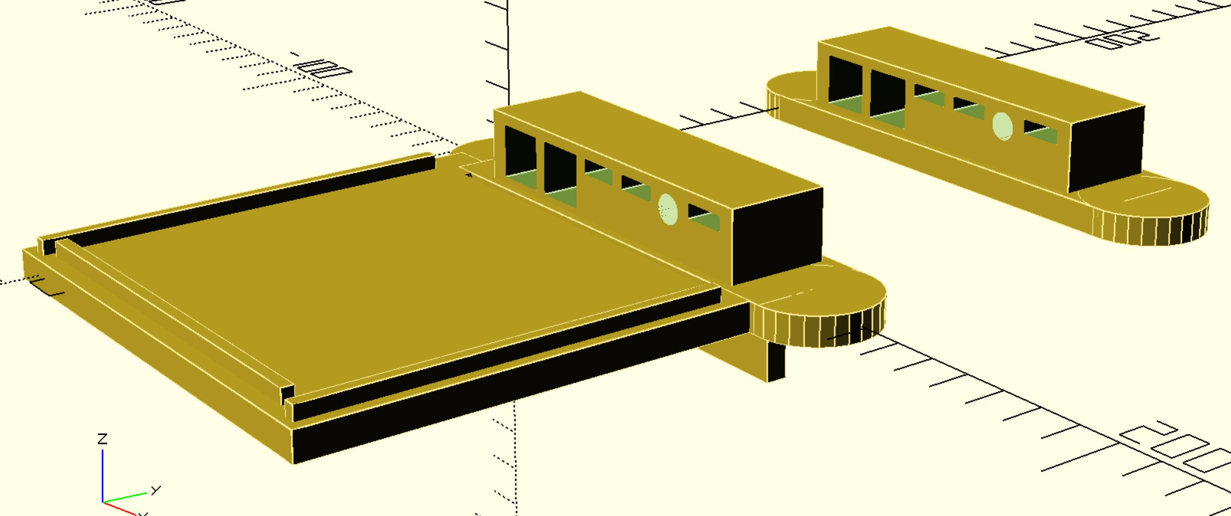

**Touch Detection:** Determined how to use household wiring copper wire (not enamelled) for detecting all and any non-ball-bearing touch events. The wire on the rotor is, by design, not connected to any electronics. It can be threaded through printed holes and twisted tight. The twist can be safely and symmetrically concealed under a spoke attachment point. There will be 12 spokes, as there will be 12 touch detection points.] I have the wire. These 13 stator wires have to pass through waterproof grommets.

**Magnetic Circuit Model:** I have been 3D modelling the magnetic circuit. I find it quite charming that this circuit replicated 48 times as it is rotated round a circuit is made up from a hierarchy of files --- and then interestingly, this geometry of 48 circuits is reused three times to subtract space from i) the main body of the stator, ii) the left side of the rotor and iii) the right side of the rotor. What gets subtracted depends on the positioning of space of the circuits array. The rotor has to be in two parts so that it can be clamped around the stator and not fall off in use.

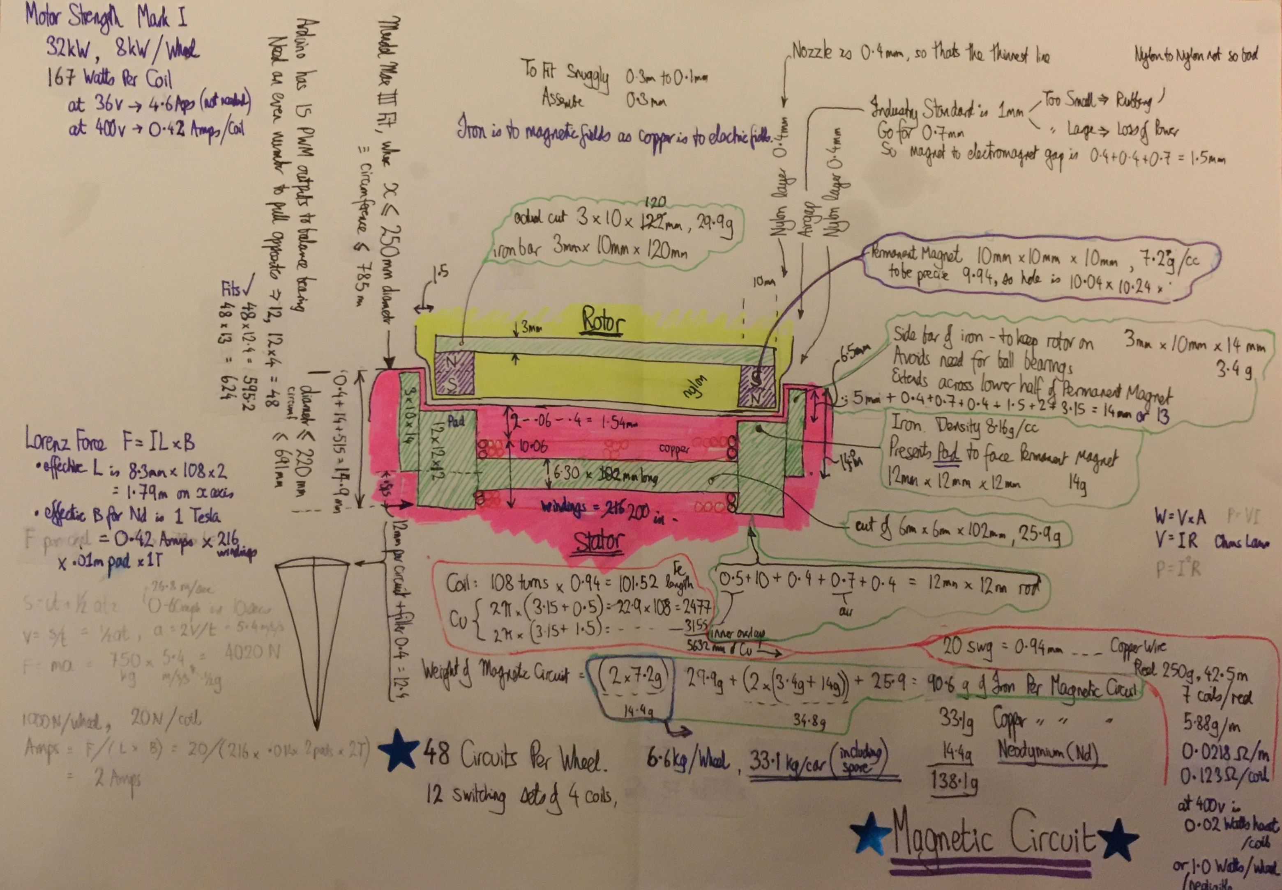

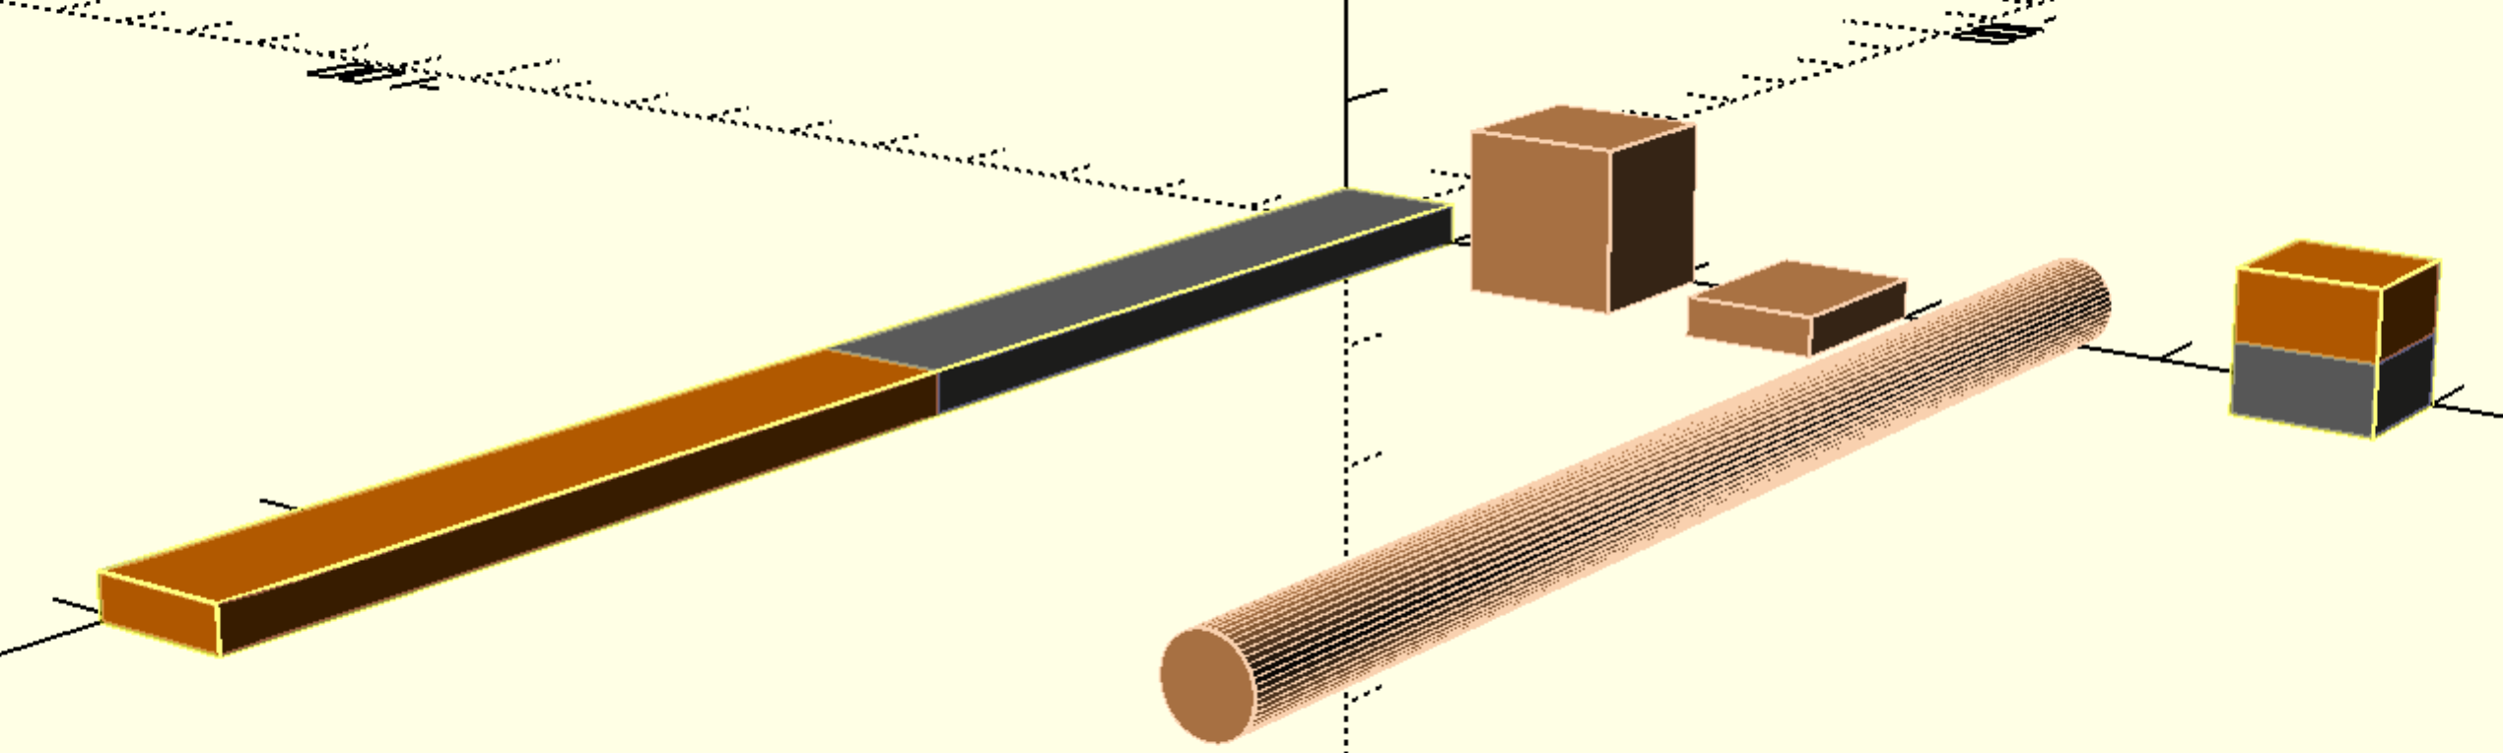 These parts have a yellow tinge as they are wrapped in yellow containers to model the holes that have to be made in the nylon to embed them in.

**Rattle Prevention:** There are three problems with embedding the parts of the magnetic circuit within the 3D printed nylon. One is that they would rattle – to insert a part into a hole needs a 0.3mm gap (both sides added together) to allow easy insertion. If the printing was paused as the top edge of the hole is reached, the metal inserted, printing resumed and a lid printed on the top of the metal – it would still leave rattle room around the metal. Now for two: The air gap, between permanent magnet in the rotor and electromagnet in the stator needs to be as small as possible [ours is set at 1.5mm, being 0.4mm nylon, 0.7mm air, 0.4mm nylon, where the print nozzle is 0.4mm and 0.4mm is the smallest reasonable print width]. If the parts each ratted 0.3mm away that would add 0.6mm to the airgap, which is too much. The third problem is that if parts are embedded and then the print fails, how do you get the metal out again? Hard.

* A better solution, I am designing, is to have a cover on each set of metal bits, that when bolted down eliminates all rattle and holds the parts as close to each other as possible. There will be 48 covers in the stator and 48 in the rotor, with at least two bolts and a waterproof seal each.

1. Parts Sourcing
   1. Bought & Delivered: Amp meter – at least 10 amps, if not 20 amps
   2. Bought & Delivered: Insets to screw metal into, and inset into plastic. 2 per circuit (2 x 48 = 96) plus one per touch detector (14).
   3. Bought: Iron stock (saw blade is 1mm wide). I have placed an order with MetalBits so that I have plenty enough metal for one wheel, but not for a car.
      1. 6mm rod – 100mm. Need 100 x 48 = 4800mm = 5m, call it 6m as the ends are a bit squashed. B&Q. Buy 2m
      2. *12mm square rod – Need 13 * 48 * 2 = 1248mm – I have 2m x 2 is enough.*
      3. 10x3mm rod – Need (121mm * 48) + (14mm * 48 * 2) = 7152mm , ie 8m. Metalbits, I past ordered 2m with 8 free cuts of 120mm – need to order 6m more, which I’ll cut. I need to recut all of these at 121mm so that wheel spins symmetrically. Cut up the 120mm ones into 14mm.
   4. Bought & Delivered: More copper wire [4 reels of 20 SWG from Maplin] as pads allow for 3 (not 2) rotations (given the way the main pads have to be at least 11.5mm to provide support for the end pads to stop the rotor falling off sideways).
   5. Bought & Delivered: an SD card to move data from red lap top to 3D printer, to allow it to print off line.
   6. Bought: red anodized aluminium M8 hex bolts for screwing down all covers that house high voltage. Being so big they are easy remove, and not load bearing so red is OK. I am very particular on safety!
   7. To purchase: Bolts for spokes – or perhaps use off the shelf bicycle spokes that are shorter (if available).
   8. To purchase: embedding nuts for M8s.

# To Do Next (not quite ‘This Week ‘bound yet):

* **Jig:** Complete Jig OpenSCAD and print the rest of it.
* Layout full magnetic circuit in OpenSCAD, calculate exact sizes.
* Layout rotor and stator in OpenSCAD, with magnetic circuit subtracted from these three parts. Detail how the covers work. There is also the optical circuit to finalise the design of and to print the parts for.
* Print the rotor, stator, lid, and two parts for the optical circuit.
* **Bearing**: Install the ball bearings so that the filament doesn’t stop flowing.
* **Cut, Cut, Cut** all the pieces of Metal using above jig
* **Jig 2:** Create another 3D printed jig to make it easier to wind the coils using the power drill to provide the rotation.
* **Wind, Wind, Wind** the 48 coils with 3 x 100 turns a piece = roughly 15,000 turns. How long will that help. (A friend of ours Debbie has adopted a teenage boy Hamish who is apparently interested to volunteer help – talk to Debbie).
* **Current Control:** Learn better how the Arduino software a) measures current and b) controls current. In lieu of a deeper understanding it is pulse width modulation (PWM) control of voltage that in turn controls current. Remember that magnetic fields take time to build and collapse. Measuring current, by default, is with an ammeter.
* **Maximum Current:** Recap my learning about maximum current per battery cell and design protection (using PWM) to ensure that start up doesn’t suck too much current.
* **Circuit Diagram:** Draw exactly the circuit diagram for Wheel Mark I (consolidating many sketches I have). This diagram is well begun in Omnigraffle. Proceed to precise layout of components on printed circuit boards.
* **Power Measurement.** Need to design and implement measurement of volts, amps by electronics and reporting of it from the wheel, up to a laptop (later to the Raspberry Pi in-car management computer).
* **Service Architecture:** design the information messages to and from the wheel. For example Tdddddttttnn is the format of the Touch event reports, where d is for date, t for time down to milliseconds and nn is the number of the circuit that has touched (1 to 14). [revise how time is tracked in Arduino; I know it counts microseconds and I think it doesn’t know about the date].

# Features in Wheel Mark I

* Traction – runs at 36 volts.
* Photo sensors only for position, with Grey’s Disk.
* Manual monitoring of temperature and humidity, by hand (finger tip) only.
* Software: Polled, without delays, without interrupts
* Touch detection to identify if, where and when the stator and rotor touch. Furthermore if they do touch then the software adjusts the PWM to equal the spin.
* Mark I does not attempt to be waterproof, it contains no seals.
* Risks to mitigate
  + Ensure the basics that the motor rotates and pulls.
  + Ensure that rotation is free from rubbing (first mitigation is PWM adjusting pulling across 12 sectors around the wheel).(second mitigation, in extremis would be to add ball bearings, but I want to avoid that).
  + Ensure that the motor pulls the bicycle up a hill OK. The hill linking our lower and higher drives is a good one for testing – and to video!
  + Ensure that the battery is not drained too quickly. Calculate efficiency of energy in and energy out. Clearly the 36v lawnmower battery (and the two sets of 18650 Lithium Ion cells that I have to match the lawnmower battery) won’t have that long a life (they are rechargeable) between charges as they are way smaller than the Zoe’s 22kWh. They are 148 watt hours, which is 150th of the Zoe’s.

# Features in Wheel Mark II+

* **Waterproof**, so that whole wheel can be submersed in a ford and keep working. The milder test is driving through puddles.
* Electronic monitoring of **temperature** within hub
* Electronic monitoring of **humidity** within hub (to detect water leaks)
* **Hall** effect magnetic sensor to back up photo sensors for position
* Accelerometer
* **Interrupt** based software, where all 12 touch sensors feed through an OR gate into one interrupt. The interrupt then polls the 12 touch sensors (very quickly) to see which one or ones have touched.

Wheel in Due Course

* Will run at 400 volts.
* Series of functions to enhance traction, prevent wheel dragging and prevent skids.
* Commands to control position, speed and acceleration.

# 3D Printer Completion

1. Adjust X axis constants so that it will print the full 250mm (needed for stator).
2. Set up SD card to remove control
3. Move control card to left and towards rear to better enable cable tidy up
4. Print chain to tidy cable up in X and Z directions.
5. Dual print head
6. Move up to printing in nylon
7. Build a glass box around the printer.

In other news we got another electric car. It’s a BMW i3, which has a much larger motor than the Zoe (about 125 kW) but the same size battery (22 kWh). The car is Liz’s!